Experiment 18: 74HC595 experiment
74HC595 simply say to is the displacement of 8 bit registers and a memory, and three state output function. Here we use it to control 8 LED lights. Why should we used 74HC595 to control lights?There must be many friends will ask this question, I would like to ask is if we simply use an Arduino control 8 lights to be occupied by the number of I / O?? the answer is eight, but our Arduino 168 have several I / O port?? with analog interface is 20., the eight lights occupied the too many resources the, we 74HC595 is to reduce use of the number of I / O port. With 74HC595 after we can use three digital I / O port control 8 LED lights wouldn't it be wonderful to。
Here are the components that we need to prepare.
In 74HC595 chip *1

The red line M5 LED*4

The green line M5 LED*4

220 ohm line resistance *8

Bread board *1

Bread board jumper *1 tie
We are ready to connect the circuit according to the schematic below.
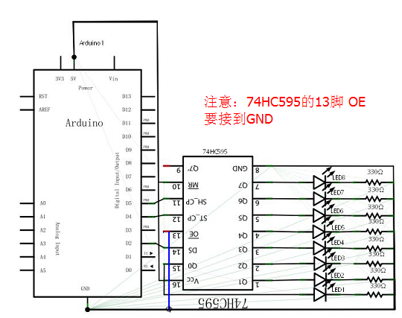
Note: OE 74HC595 feet, to connect to the GND.
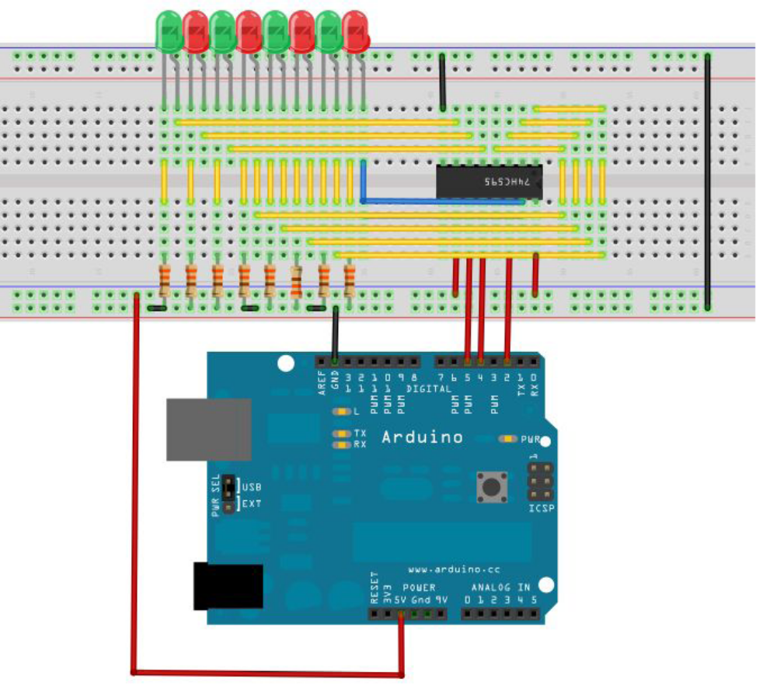
Note: OE 74HC595 feet, to connect to the GND.

This circuit is seemingly complex, we will find it very easy to find a reference in kind after careful analysis.
The following is a reference to source program:
int data = 2;//74HC595 14 pin data input pin SI
int clock = 5;//74HC595 11 pin clock line SCK
int latch = 4;//74hc595 12 pin output memory latch line RCK
int ledState = 0;
const int ON = HIGH;
const int OFF = LOW;
void setup()
{
pinMode(data, OUTPUT);
pinMode(clock, OUTPUT);
pinMode(latch, OUTPUT);
}
void loop()
{
for(int i = 0; i < 256; i++)
{
updateLEDs(i);
delay(500);
}
}
void updateLEDs(int value)
{
digitalWrite(latch, LOW);//
shiftOut(data, clock, MSBFIRST, ~value);//Serial data output, high priority

digitalWrite(latch, HIGH);//Latch
}
You can see 8 lights flashing beautiful scene download program.

The experimental phenomenon is to see the eight bit LED display eight bit binary number, loop self plus 1

